Chapter 3:Testing Results
In my test, for each combination of N and the type of algorithm, I created a input file(*.in). And every input file is consist of 5 groups of random matrices with certain size(N*N). After running the programs, we can get several output files(*.out), which contain the ticks and total time.
But each pair of ticks and total time means the ticks and total time of the period when the computer calculate a given matrix for K times. Thus, if we want to get the ticks and total time filled in the table following, we should sum all ticks/total time in a same output file up and divide it by 5(the number of groups). Afterwards, divided the total time and you can get the duration, which means the time spent on articulating a single matrix with certain size,using a certain algorithm.
Then let’s talk about how to select the proper size of K. At first, I noticed that if the program adopting O(N^4) Version run for 10 times, the TotalTime would be approximately 1 sec(0.842), which was really suitable for test. According to the time complexities of the algorithm, the formula K=(int)1600000/(N/5)^4 was created by me. Later, I replace the exponent 4 with 3 and 6. As for O(N^6) Version, I made some other changes to ensure that all Ks are no less than 1, and that the time during tests is not too long to wait.
Formula:
O(N^6) Version: K=(int)160000/(N/5)^6 , N<=30
K=1 , N>30
O(N^4) Version: K=(int)1600000/(N/5)^4
O(N^3) Version: K=(int)1600000/(N/5)^3
Ticks=(Ticks1+Ticks2+...+Ticks5)/5;
TotalTime=(TotalTime1+TotalTime2+...+TotalTime5)/5;
Duration=TotalTime/K;
 | N | 5 | 10 | 30 | 50 | 80 | 100
O(N^6) Version | Iterations(K) | 160000 | 2500 | 3 | 1 | 1 | 1
O(N^6) Version | Ticks | 657 | 344 | 185 | 1309 | 21728 | 79736
O(N^6) Version | Total Time(sec) | 0.657 | 0.344 | 0.185 | 1.309 | 21.728 | 79.736
O(N^6) Version | Duration(sec) | 4.106E-06 | 1.376E-04 | 6.167E-02 | 1.309E+00 | 2.173E+01 | 7.974E+01
O(N^4) Version | Iterations(K) | 1600000 | 100000 | 1234 | 160 | 24 | 10
O(N^4) Version | Ticks | 1666 | 1033 | 890 | 870 | 921 | 842
O(N^4) Version | Total Time(sec) | 1.666 | 1.033 | 0.89 | 0.87 | 0.921 | 0.842
O(N^4) Version | Duration(sec) | 1.041E-06 | 1.033E-05 | 7.212E-04 | 5.438E-03 | 3.838E-02 | 8.420E-02
O(N^3) Version | Iterations(K) | 1600000 | 200000 | 7407 | 1600 | 390 | 200
O(N^3) Version | Ticks | 891 | 702 | 1012 | 925 | 829 | 1038
O(N^3) Version | Total Time(sec) | 0.891 | 0.702 | 1.012 | 0.925 | 0.829 | 1.038
O(N^3) Version | Duration(sec) | 5.569E-07 | 3.510E-06 | 1.366E-04 | 5.781E-04 | 2.126E-03 | 5.190E-03
Current Status: pass

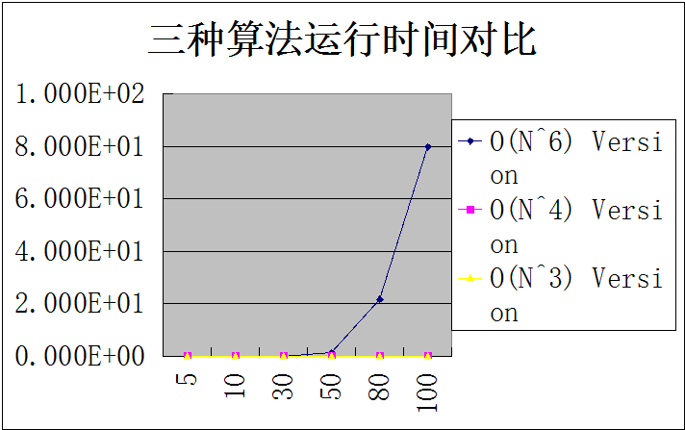

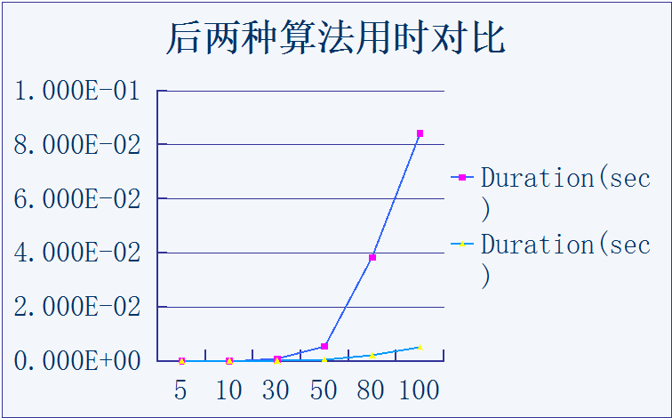
Chapter 4:Comments
//search all the matrix
//(stx,sty) is the starting point
for(testi=1;testi<=testtimes;testi++){
max=0;
for (stx=1;stx<=n;stx++) //n times
for (sty=1;sty<=n;sty++) //n times
//(enx,eny) is the end point
for (enx=stx;enx<=n;enx++) //n,n-1,n-2...1 times
for (eny=sty;eny<=n;eny++) //n,n-1,n-2...1 times {
//sum represents the sum of the current matrix
sum=0;
for (i=stx;i<=enx;i++) //<=n times
for (j=sty;j<=eny;j++) ///<=n times
{
sum+=a[i][j];

}
if (sum>max) max=sum;
}

}
Time Complexity of algorithm 1: O(n^6)
Space Complexity of algorithm 1: O(n^2) (The array a)

for(testi=1;testi<=testtimes;testi++){
max=0;
for (i=1;i<=n;i++)//n times
{
memset(pre,0,sizeof(pre));
for (j=i;j<=n;j++)//n times
{
//calculate the sum of the kth column from the ith row to the jth row
for (k=1;k<=n;k++)//n times
pre[k]+=a[j][k];
//the following is just like the O(n^2) algorithm of one-dimensional //problem
for (sty=1;sty<=n;sty++)//n times
{
sum=0;
for (y=sty;y<=n;y++)//<=//n times
{
sum+=pre[y];
if (sum>max) max=sum;
}
}
}
}
}
Time Complexity of algorithm 2: n*n*(n+n)*n --> O(n^4)
Space Complexity of algorithm 2: O(n^2+n)=O(n^2) (The array a and pre)

for (i=1;i<=n;i++)//n times
{
memset(sum,0,sizeof(sum));
for (j=i;j<=n;j++) //n times
{
sum1=0;
max=0;
//calculate the sum of the kth column from the ith row to the jth row
for (k=1;k<=n;k++)//n times
sum[k]+=a[j][k];

//then we can solve the problem by the algorithm of one-dimensional problem
for (k=1;k<=n;k++)//n times
{
if (sum1>0) sum1+=sum[k];//if the previous is positive then it may be in //the answer
else sum1=sum[k];//else we just drop it and restart from sum[k]
if (sum1>max) max=sum1;
}
if (max>ans)ans=max;
}
}

}
Time Complexity of algorithm 3: n*n*(n+n) --> O(n^3)
Space Complexity of algorithm 3: O(n^2+n)=O(n^2) (The array a and sum)

Firstly, obviously, the space complexity of these 3 algorithms are really close to each other, and we can declare that memory is not the major thing we should consider of this problem.
Comparing the time complexity of algorithm with the diagrams above, I find out that as the size of N grows the time of algorithm1 rises much faster than other 2 algorithms. Even the curves of algorithm2 and algorithm3 are nearly coincident if we put 3 algorithm into the same graph.
When I separate the curve of algorithm from the graph, there’s no doubt that the growth rate of algorithm2 is much more higher than algorithm3.
All in all, if the size of N is large enough, the trends of these 3 algorithms all correspond to their time complexity well. The algorithm3 performs so well that I can hardly think of possible improvements. If any, the capabilities of the array a and sum are decided numbers, I think they could be changed according to the size of n(after reading the variable n, use malloc() to distribute each array some just right memory space ).

